**Experiment Number – 1:**

**Submit By: Name: Md Saiful Islam ID: 18-36363-1 Course: Electronic Device**

**Title: V-I characteristic of a diode.**

**Group Leader: Aminul Islam (19-39571-1)**

**Group members:**

**1. MD Saiful Islam (18-36363-1)**

**2. Aminul Islam (19-39571-1)**

**3. Rhisul Islam (19-41018-2)**

**4. SHAON, INDROJIT DHE (18-38674-3)**

**5. Md sakib hossain zisan (18-37823-2)**

**Introduction:**

We try to see the Voltage-Current realtion in Diodes by applying a voltage across it and measuring the corressponding current flowing through it.

**Theory:**

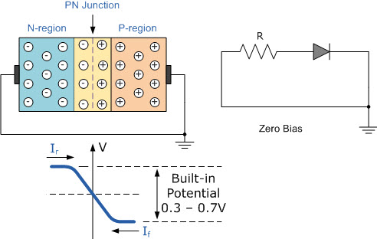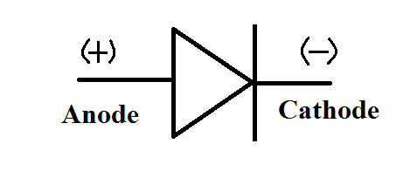The diode is a device formed from a junction of n-type and p-type semiconductor material. The lead connected to the p-type material is called the anode and the lead connected to the n-type material is the cathode. In general, the cathode of a diode is marked by a solid line on the diode.The primary function of the diode is rectification. When it is forward biased (the higher potential is connected to the anode lead), it will pass current. When it is reversed biased ( the higher potential is connected to the cathode lead), current flow is blocked.

**Apparatus:**

1. A diode

2. A DC voltage supplier

3. Bread board

4. 5Ω resistor

5. multimeter for measuring current and voltage

6. Connecting wires

**Circuit Diagram:**

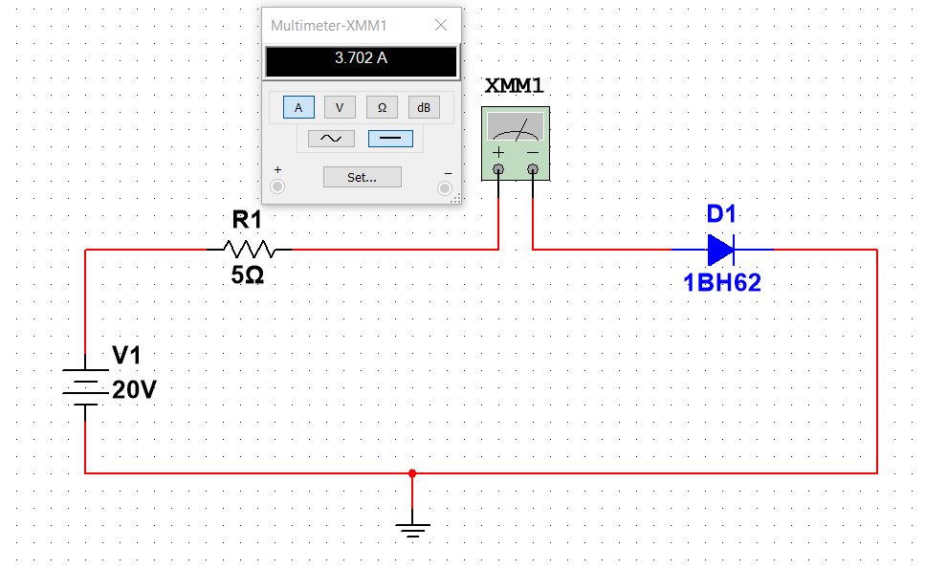

Figure 1: Circuit Diagram of V-I Characteristic of Diode

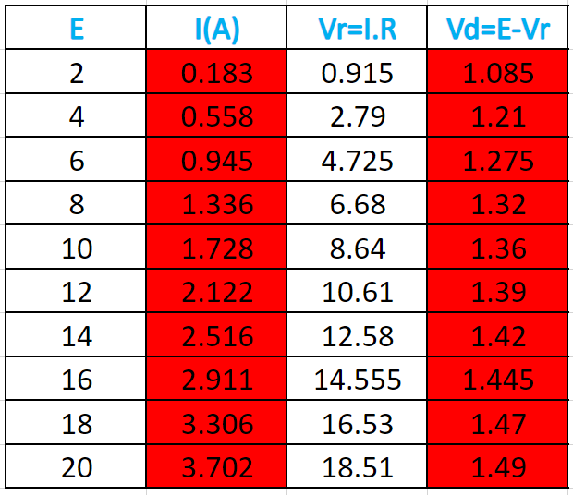**Calculation:**

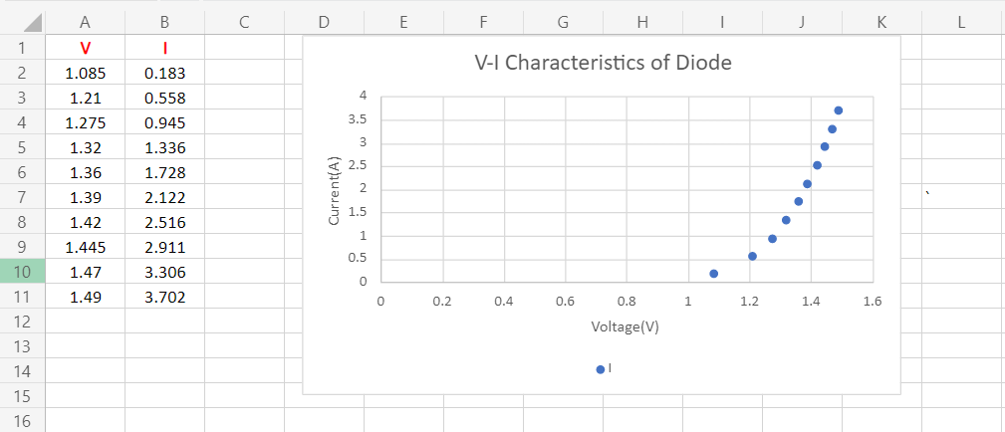

Figure 2: V-I Characteristic of Diode curve I Vs V.

**Discussion:**

Forward Bias direction current can be followed but reverse bias direction current can not be followed. If, we just reverse the diode to measure the I-V characteristics, the sudden change might destroy the diode. The diode should not be short-circuited. That will allow a flow of huge current which might destroy the diode. Current must not pass through it for a very long time. It will then increase the depletion region and develop a fluctuating resistance.